Areas Where HR Can Apply Some Creativity
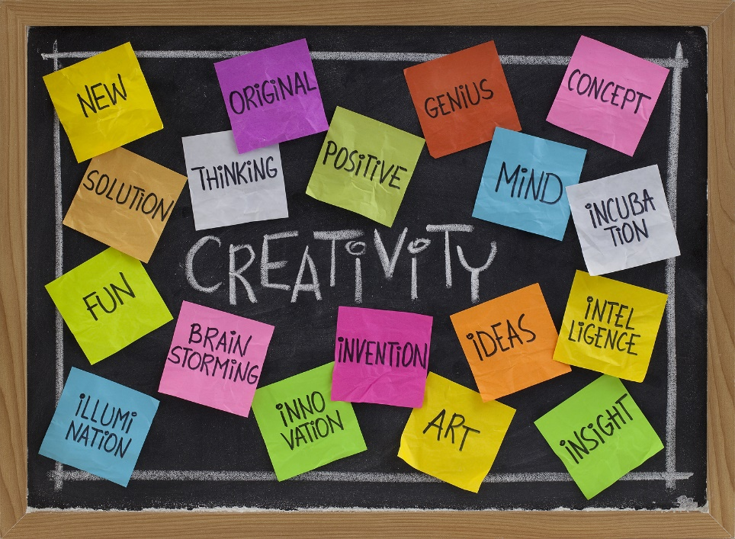

Everyone is creative…if they choose to be. There are never-ending opportunities to be creative in HR…

- Recruiting
- Referral programs
- Hiring
- Onboarding
- Performance management
- Recognition and reward
- Training and development

- Offboarding
- DEI Initiatives
- Career development
- Attendance and time off
- Data management
- Internal branding
- Benefits
- Wellness
- How to have fun!
- Community outreach
- Gamification…of everything
- Technology implementation
- Surveys and focus groups
- Innovation (Kaizen) meetings
Where will you apply some creativity in HR? See the Creativity Checklist and the A to Z of Work Ideas and Questions

